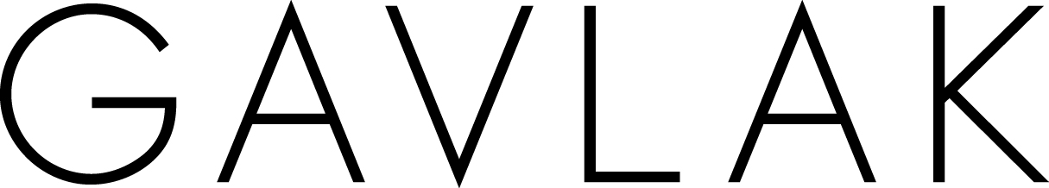
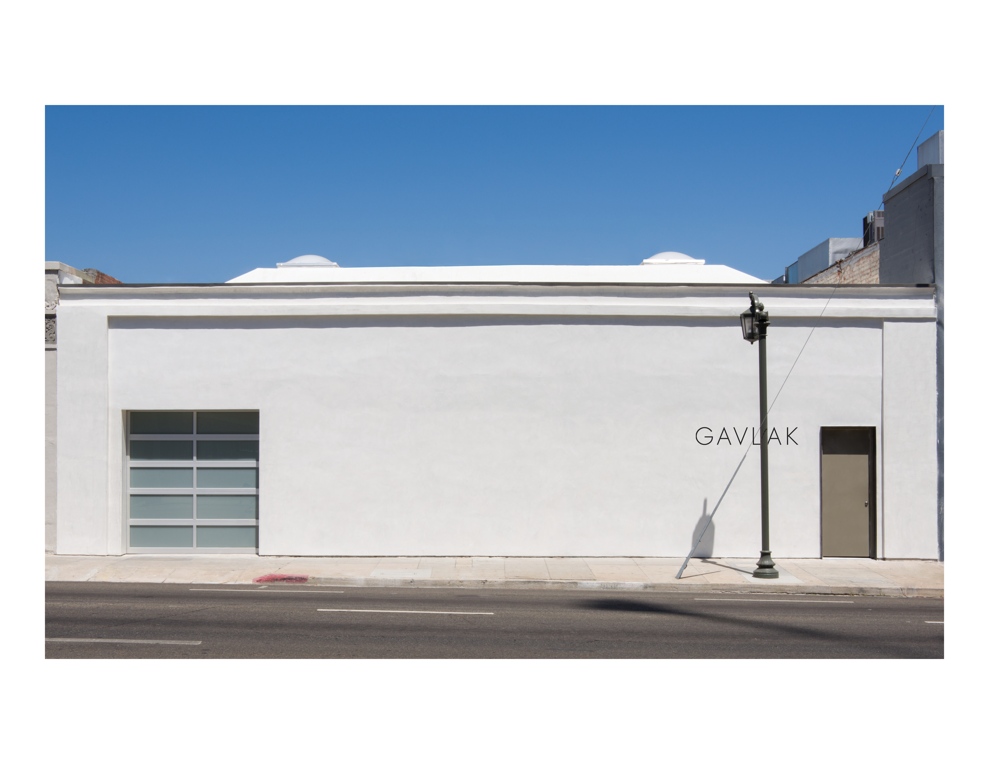
Sarah Gavlak Announces Opening of Gallery in Los Angeles

Gavlak to expand flagship gallery in Palm Beach
by opening a second space in Hollywood at
1034 North Highland Avenue

Opening:
Thursday, June 26, 6-8pm

June 18, 2014 (Los Angeles)—Sarah Gavlak is pleased to announce the opening of a second eponymous gallery, Gavlak, in the Hollywood neighborhood of Los Angeles, at 1034 North Highland Avenue. The 5,000 square foot new space will allow Miss Gavlak to stage larger and more ambitious exhibitions by her group of international contemporary artists.

The Los Angeles location will also enable Gavlak to exhibit the talent of an expanded range of artists living and working in the area and elsewhere. The inaugural exhibition, opening on June 26, will feature works by gallery artists: Jose Alvarez (D.O.P.A.), Andrew Brischler, Judith Eisler, Orly Genger, David Haxton, Bovey Lee, Simone Leigh, Keith Mayerson, McDermott & McGough, Maynard Monrow, Scott Reeder, Alexis Marguerite Teplin, Betty Tompkins, T.J. Wilcox, Rob Wynne, Bunny Yeager; as well as Lisa Anne Auerbach, Judie Bamber, Liz Craft, Lecia Dole-Recio, Michael John Kelly, and Vincent Szarek, who live and work in Los Angeles.

By opening a gallery in Los Angeles, Gavlak continues her long and deep history with the city’s cultural landscape. After completing her Art History degree in Pittsburgh where she grew up, Gavlak moved to Los Angeles in 1992 and immersed herself in the art scene, working for several public institutions such as LACE (Los Angeles Contemporary Exhibitions), MOCA, and the LA Forum for Architecture and Urban Design at the Schindler House, where she organized a lecture series. She also studied critical theory at the Art Center College of Design in Pasadena from 1996 - 1998, and during that time started a project space in her Silver Lake home.

Gavlak also worked closely with dealer Christine Nichols at her gallery, Works on Paper, and collaborated with a wide array of international emerging and established artists including Jeremy Blake, Miles Coolidge, Charlene von Heyl, Catherine Opie, Jorge Pardo, and Pae White, among others.

In 2000, Gavlak relocated to New York to pursue independent curating and writing, contributing to Time Out New York, Art Review, Purple, and Bidoun. During this time she also worked for Art Production Fund and Gagosian Gallery, brought on by her longtime mentor, Robert Shapazian.

While working in New York and visiting Palm Beach, Gavlak saw the need for a serious contemporary art gallery to serve the community of collectors with winter homes in that area. Thus, in 2005, Gavlak relocated to West Palm Beach and opened her first gallery with an inaugural exhibition of work by Wade Guyton, giving him one of his first solo gallery exhibitions in America. The gallery also presented early exhibitions of artists Marilyn Minter and Aleksandra Mir. In 2008, collector and Palm Beach resident Jane Holzer invited Gavlak to move the gallery to one of her properties in the tony section of Worth Avenue in Palm Beach where it has continued to be a destination for collectors who seek the best representation of international contemporary art.

“I am thrilled to be coming back to LA and making this vibrant community the home for the next exciting phase of the gallery. It’s like a homecoming as I have such close friends, artists, curators, and collectors that I have continued to work with since I lived here in the ‘90s. I look forward to being a part of this artist-driven community again and doing great exhibitions with artists who do not have representation in LA,” says Sarah Gavlak.

The new space is centrally located on North Highland Avenue, and Gavlak is honored to be neighboring acclaimed international galleries like Hannah Hoffman Gallery, Michael Kohn Gallery, and Regen Projects.

Media Contact:
Justin Conner
Third Eye
Justin@hellothirdeye.com
+1 917 609 8499

